**AIM:** Develop Gantt Chart and PERT chart for Online Ticket Booking system of PVR cinema.

1. **PERT Chart**

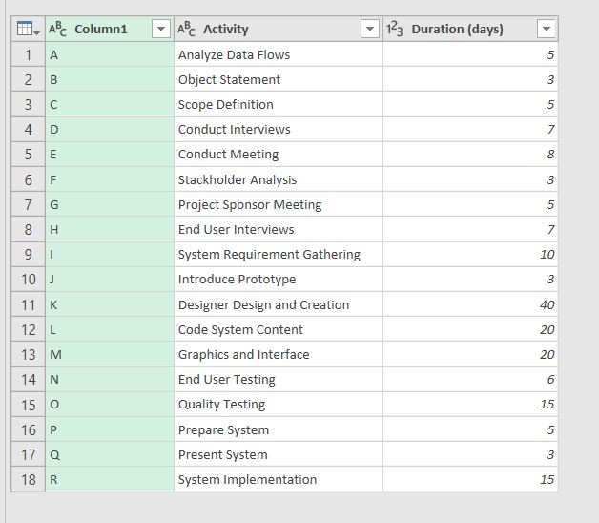



1. **Gantt Chart**

